Love at first sight?
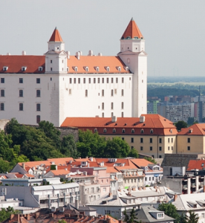With Bratislava, you don’t fall in love at first sight. She’s not that kind of city. She’s a pretty city in many ways but she doesn’t use her beauty to beguile you. She’s not coquettish in the slightest and she never flirts with you at all.
Bratislava is private and reserved. Sometimes she even comes across as cold and stand-offish. Over time, however, you realize this is pure shyness. Not arrogance. She has lived for years in the shadow of older, more extrovert sisters, Vienna and Budapest, who’ve traditionally hogged the limelight, leaving her to play second or third fiddle or no fiddle at all.
Bratislava doesn’t do one-night stands. She doesn’t let you get that close so quickly. You have to earn her trust and, in the time that takes, she lets you get to know her, gradually, tentatively, modestly.
Back in Bratislava
@Supergreybeard and I were back in Bratislava again to work with the local MICE community on the creation of a brand value proposition for the city to increase its profile for international buyers of meetings, incentives, conferences and events. In trying to capture something of the essence of the city I found myself still playing with imagery that I had used in a previous post about the city:
Bratislava is … the embarrassed, shy girl at the party, conscious of her frumpy clothes, lingering in the corner and nodding hopefully at anyone who looks in her direction. But anyone who has given this humble girl a second glance knows she’s a real looker, gracious and natural, highly intelligent and fashionably edgy. The party guest, in fact, that could easily be its life and soul if she could upgrade her outfit a little, be more self-assured and start to smile.
It’s hard to nail Bratislava, probably because she’s a city in transition. She’s fleeting and evasive, inconsistent and ambivalent, moody and unsettled. That said, there’s a strength and depth of personality under the skin of this city that you detect when you spend time there and especially when you talk to the thinkers and dreamers who have made this city their home.
Thinkers and Dreamers
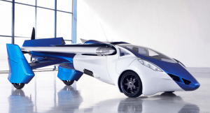During this visit we talked and drank a lot of coffee with fascinating array of creatives, academics, corporates and politicos. We wanted to drill down below the city’s surface infrastructure – her hotels, meetings venues, visitor attractions etc – to mine those hidden, ultimately more valuable resources that can make Bratislava an important destination for MICE. This approach was ultimately influenced by the way leading destinations around the world are marketing themselves with emphasis now on software and the intellectual capital of the destination rather than its hardware assets such as convention centres.
In our discussions three broad themes started to emerge under categories that we’re tentatively labelling Accessibility & Intimacy, New Thinking & Experimentation and Exceptional Execution & Making.
Accessibility & Intimacy
Robert Vincze, Head of the Slovak Convention Bureau describes the Slovak capital as the most accessible capital in the world. While this statement is made with a generous serving of poetic licence the underlying claim is not inaccurate. Bratislava is within 40 minutes of 2 international airport, the mainly low-cost Bratislava airport and the full service Vienna hub. Added to that are the rapid connections by rail, road and indeed river to other conurbations in central Europe and beyond. Getting around the intimate, compact city is easy too with a well developed bus and tram network and roads remarkably free from traffic. The surrounding countryside, a haven for hikers, bikers and outdoor enthusiasts, is reached in minutes.
But accessibility in Bratislava is more than air access. Many of the individuals we spoke with mentioned how connected business is with politics (in a good way!) and how accessible Slovakia’s President, Andrej Kiska, is to the business community. A former entrepreneur who, before running for President, donated his company’s profits to charity, Kiska is personally committed to enhancing Bratislava’s reputation as new emerging technology and start-up hub and regularly turns up to launches.
New Thinking and Experimentation
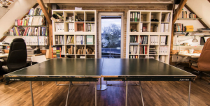If Bratislava is at a point of transition or crossroads, it’s because there’s a new wind blowing through the city, gradually replacing the stale old wind of bureaucratic stasis and lost-in-the-past inertia. All of our interviewees admitted that it’s not there yet and some expressed frustration at the pace of change and the dogged way the old thinking is hanging on.
The start-up ecosystem in Bratislava is expanding rapidly with proactive government assistance and, as mentioned above, the personal support of the country’s president. The poster-boys of the ecosystem are, of course, ESET (valued at over 1bn and ranked amongst the Top 5 antivirus softwares in the world) and Pixel Federation (which makes games for Facebook). MICE professionals, of course, will be familiar with Sli.do, the audience engagement platform that’s having a huge, positive impact on how conferences and meetings are run these days. All over the city there’s a plethora of incubator units and co-working spaces that foster entrepreneurship and new thinking.
Exceptional Execution & Making
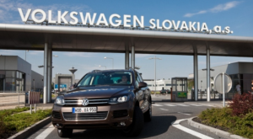Slovakia has a long tradition as a manufacturing location and even today, out of 1500 companies trading in the country, 70% are classed as heavy industry. The know-how and skill set that results from this legacy has led to an extraordinary influx of global automotive plants for Volkswagen, PSA Peugeot Citroën and KIA with Jaguar rumoured to be en route.
The Volkswagen plant, in particular, has been pioneering some of the most advanced and cutting edge robotics technology and is regarded as a world leader for exceptional execution in manufacturing. The scope for combining a burgeoning start-up ecosystem with a peerless legacy in manufacturing augurs well for a country that only declared its sovereign independence 23 years ago in 1993.
It may not be love at first sight with Bratislava but clearly the mid to long term opportunities for the city are optimistic and bright. Bratislava’s story is both deep and wide – as Pressburg, Bratislava was the coronation city linked with the Austro-Hungarian empire, its has strong gastronomic traditions and great wine, it’s a Danube city linked with Budapest and Vienna. However, for MICE buyers Bratislava differentiates itself much more compellingly when she highlights her accessibility, her new thinking and her exceptional execution.
Pádraic Gilligan and Patrick Delaney own SoolNua, a boutique consultancy working for destinations, venues and hotels on strategy, marketing and training for the MICE markets.
Written on 16. January 2016 by Pádraic Gilligan, Managing Partner, SoolNua. Read article here.

