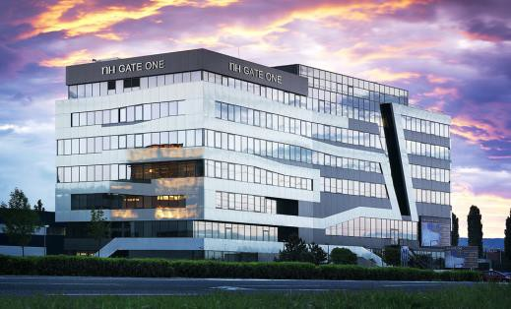
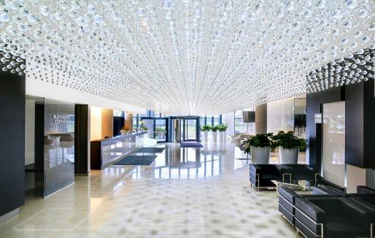
NH Bratislava Gate One Ambrušova 7
821 04 Bratislava

T: 00421 2 32 770 000
E: rsvt.nhgateone@nh-hotels.com

Booking Form
“ OBSE”

2.12.2019 – 6.12.2019
e-mail: rsvt.nhgateone@nh-hotels.com

RATES
Standard room single occupancy | 83 € | room / night
Standard room double occupancy | 93 € | room / night
Superior room single occupancy | 103 € | room / night
Superior room double occupancy | 113 € | room / night
Buffet breakfast | included
Pparking 10 €/car/night - outside
Entrance to the hotel fitness and wellness center included

VAT is included.
City tax – 1,70 € / day / person is excluded.

Above mentioned rates are available only if this booking form is fully completed and sent back to the hotel before 10.11.2019
Limited number of rooms for each room type available!

GUEST INFORMATION

Last name: First name:

e-mail:

Date of arrival: Date of departure:

Room type:
Standard room single occupancy Standard room double occupancy
Standard room double occupancy with twin bed
Superior room single occupancy Superior room double occupancy

Other requests: (please specify, optional, based on availability):

CREDIT CARD DETAILS

AMEX
MasterCard
Visa
Credit card type:
Cardholder name: Credit card number: Expiration date:
CVV code:

Please note that reservations without valid credit card number cannot be proceeded. Please indicate a card number even if you intend to use another kind of payment.

CANCELLATION POLICY
We have to charge you 100% of booked services, in case of late cancellation after 18.11.2019 or non-arrival. Only written cancellation can be accepted until 10.11.2019, without cancellation fee, or until 17.11. with 50% cancellation fee. In case of no-show (guest does not arrive), the whole stay is automatically cancelled. In case of invalid card number or insufficient funds reservation can be cancelled. The total price of the reservation will be pre-authorised before arrival.

Thank you for having chosen us, we are looking forward to welcoming you in our hotel.
